Multiuser Save
- The last update date and time stamp of the objects and models must be saved in the system.
- Upon opening object/model, the system should also read the last update date and time stamp.
- Whenever a user wants to save changes to object/model then the system must check if the last update date and time stamp is still the same as was read upon opening. If matched, then this means that the object/model is not changed since opening and allow the user to save the changes. If not matched, then this means that someone else must have changed the object/model and give a message to user saying that the object/model is updated since you opened. And ask further if he still wants to save the changes i.e., confirm and cancel buttons.
- In the case of ‘Save As’, there is no such issue.
- Further complex functionality about notification etc. will be decided later.
Document Attachment for Attribute format ‘File’
- There will be a new interface for attaching documents similar to ‘Models’ interface.
- There will be a new button beside Objects and Models. Please reduce the size of the buttons and don’t show the text on the buttons. Only show suitable icons on the buttons. The button text should be displayed upon hovering the buttons. Please not that in future there will be 2 more buttons. So, it will be total 5 buttons. That’s why we must reduce the size of the buttons and make sure that all buttons with search filter fit well.
- The left pane will contain the tree whereas the right pane will display the attached file with the help of plugins (e.g., Image viewer, PDF viewer, PowerPoint viewer and so on). At this stage in the case of MIM, the right pane will not display the file and the functionality will be developed later.
- The user should be able to create/delete folders and sub folders. There will always be a root folder with the name of the repository (e.g., MIM). The root folder can never be deleted. Please note that this is also true for ‘Objects’ and ‘Models’ trees.
- The user should be able to browse for file attachment, download the attached file, remove file and delete file. As mentioned above, the view file functionality will be developed later.
- The user should be able to link to the files in the files tree through Object’s Form. The attribute format ‘File’ will behave similar to ‘Object’ format. The default number of rows is 4. The user should be able to add/remove links to files likewise object relationships.
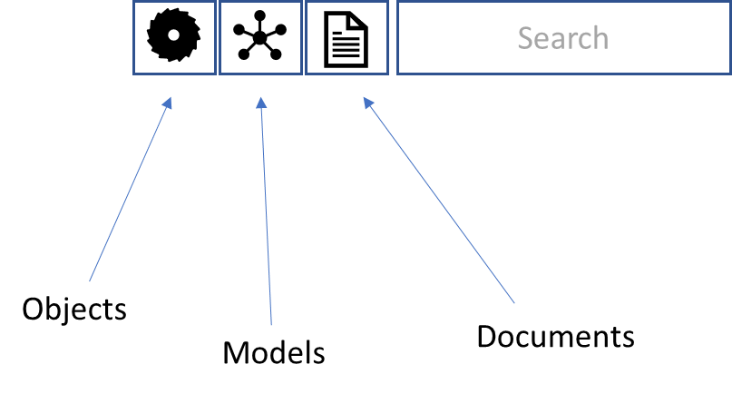
All Relationship Matrix
- All relationship matrix is an additional option in the matrix creation dialog box. In the dialog box, there must be a check box called ‘Select All Relationships’. If user checks that box then this means that the matrix will be created by checking all the available relationships for each cell. All the cells that have at least one of the relationships between the two objects will be checked.
- There will be an additional functionality that will be developed later. In this additional functionality, the cells in the matrix will be modified to contain a drop-down button as shown below. Upon clicking the button, the user will be able to see which relationships caused the cell to be checked.
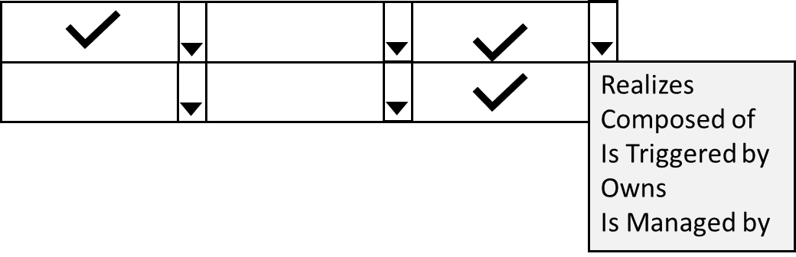

Objects Palette and My Models in My Space
- My Space should be divided into 3 panes. The 2 panes side by side likewise ‘Objects’ and ‘Models’ interfaces at the top and one horizontal pane at the bottom of the above panes.
- The top right pane will display this user’s objects with time filter as it does now. However, now the objects will by hyperlinked i.e., this user should be able to open listed objects. The object form will be opened likewise it opens in the ‘Objects’ interface. The History should work as usual.
- The top left pane will show Objects palette. A user should be able to create new objects from this palette. The object form will be opened likewise it opens in the ‘Objects’ interface. The History should work as usual.
- The bottom pane will display icons of all models created by this user. The user should be able to open models in the ‘Read Only’ mode. The model should be viewed in the top right pane. The History should work as usual.
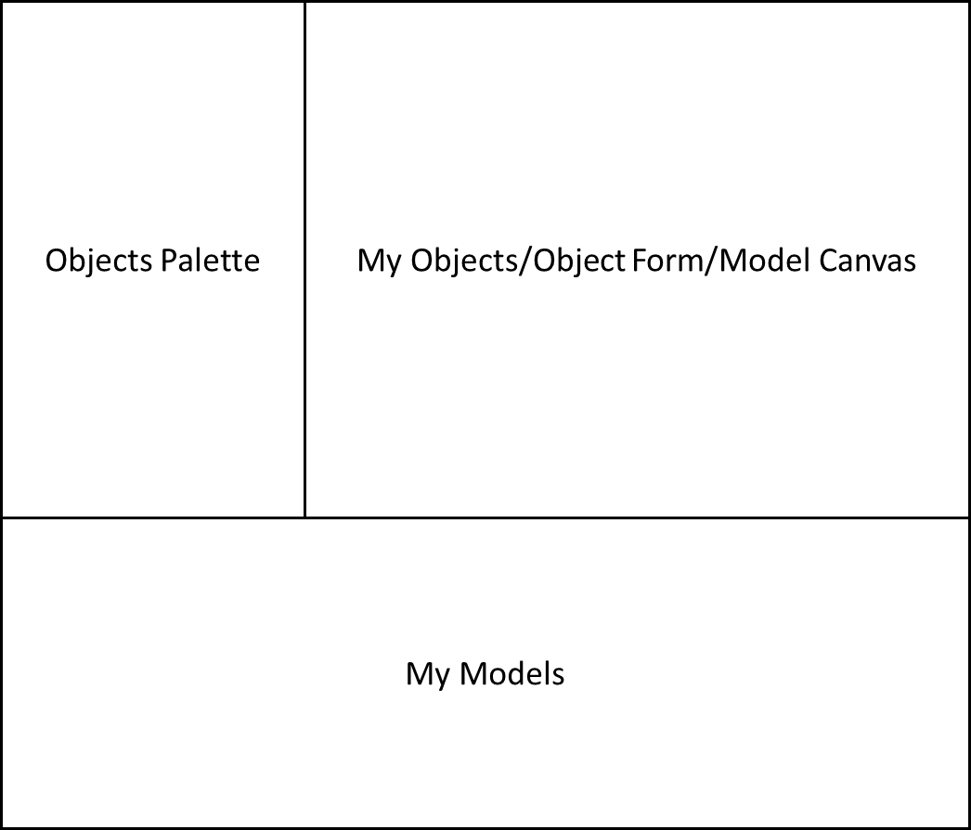
Diagram Filter
- There will be two drop down filters at the top ribbon of the diagram. The first filter will allow the user to select any Element of the meta-model. The second filter will allow to select any active object of the selected Element.
- The displayed objects will be filtered such that only those objects (and relationships) will be displayed in the diagram that have relationship with the selected object in the filter.
- The user should be able to reset the diagram i.e., display the original diagram.

Save As Button for Diagram and Navigation
- There must be a ‘Save As’ button for diagram and Navigation.
- The user must be able to Save As by providing a new name. A new entry will be created in the ‘Models’ tree below the original diagram/navigation. The original diagram/navigation must not be disturbed.
Turn-On and Turn-Off Relationship Arrows button for Diagram
- There must be a button beside the Zoom buttons of the diagram that will allow user to Turn-Off and Turn-On the relationship arrows on the diagram. The default is Turn-On i.e., relationship arrows will be displayed.
Object Shape Switch Button for Diagram
- There is another button in the Diagram ribbon that will allow user to Switch (between Boxed and Unboxed) objects display in the diagram. The default is Boxed i.e., all objects are displayed as usual with rectangular shapes with object shape inside. In Unboxed, all the objects in the diagram are displayed using shapes only i.e., without rectangular boxes. The object name will be shown below the object shape.
Object Shape and Object Name Below Object Shape in Navigation.
- The objects in the Navigation must be displayed by displaying their shapes only i.e., not inside rectangles. The object names will be displayed below the object shapes.

